**August 6, 2015**

**Special Promo offer for Authors**

## The Complete Package £75

This brand new limited time offer is called the Complete Package and the aim is to provide the tools for new writers to help them get their book published.   
I am offering beta reading and editing services for your novel, cover design, promotion to over 60k potential customers and useful advice and tips on how to create a prescence online.  
This offer is available for £75.   
 I will take you from that first draft until you hit the publish button on your chosen platform or send the book off to an agent.   
When you consider that these individual services can run into hundreds, sometimes thousands of pounds, this is a great offer. This isn't a gimmick. There are no hidden catches. I know how hard and expensive it is to get started. I've learned a lot in the last few years and I want to help other writers.



NEWS

The cover for Queen of Hell: Hell Hath No Fury is almost complete and I will be hosting a cover reveal on my site soon.

Before will be released at the end of 2015 – early 2016.

Indeadpendence Day, my new zombie novella, has been released and is available from Amazon for only 99p/$1.54.

In the meantime I will be working away on other novels and organizing Blood Moon Rising 2 (details below)

I am looking for reviewers for my new book, Indeadpendence Day and I am happy to do a review swap, if anyone is interested.

I have added covers to my site that can be purchased or I can make a cover from scratch for a reasonable price.

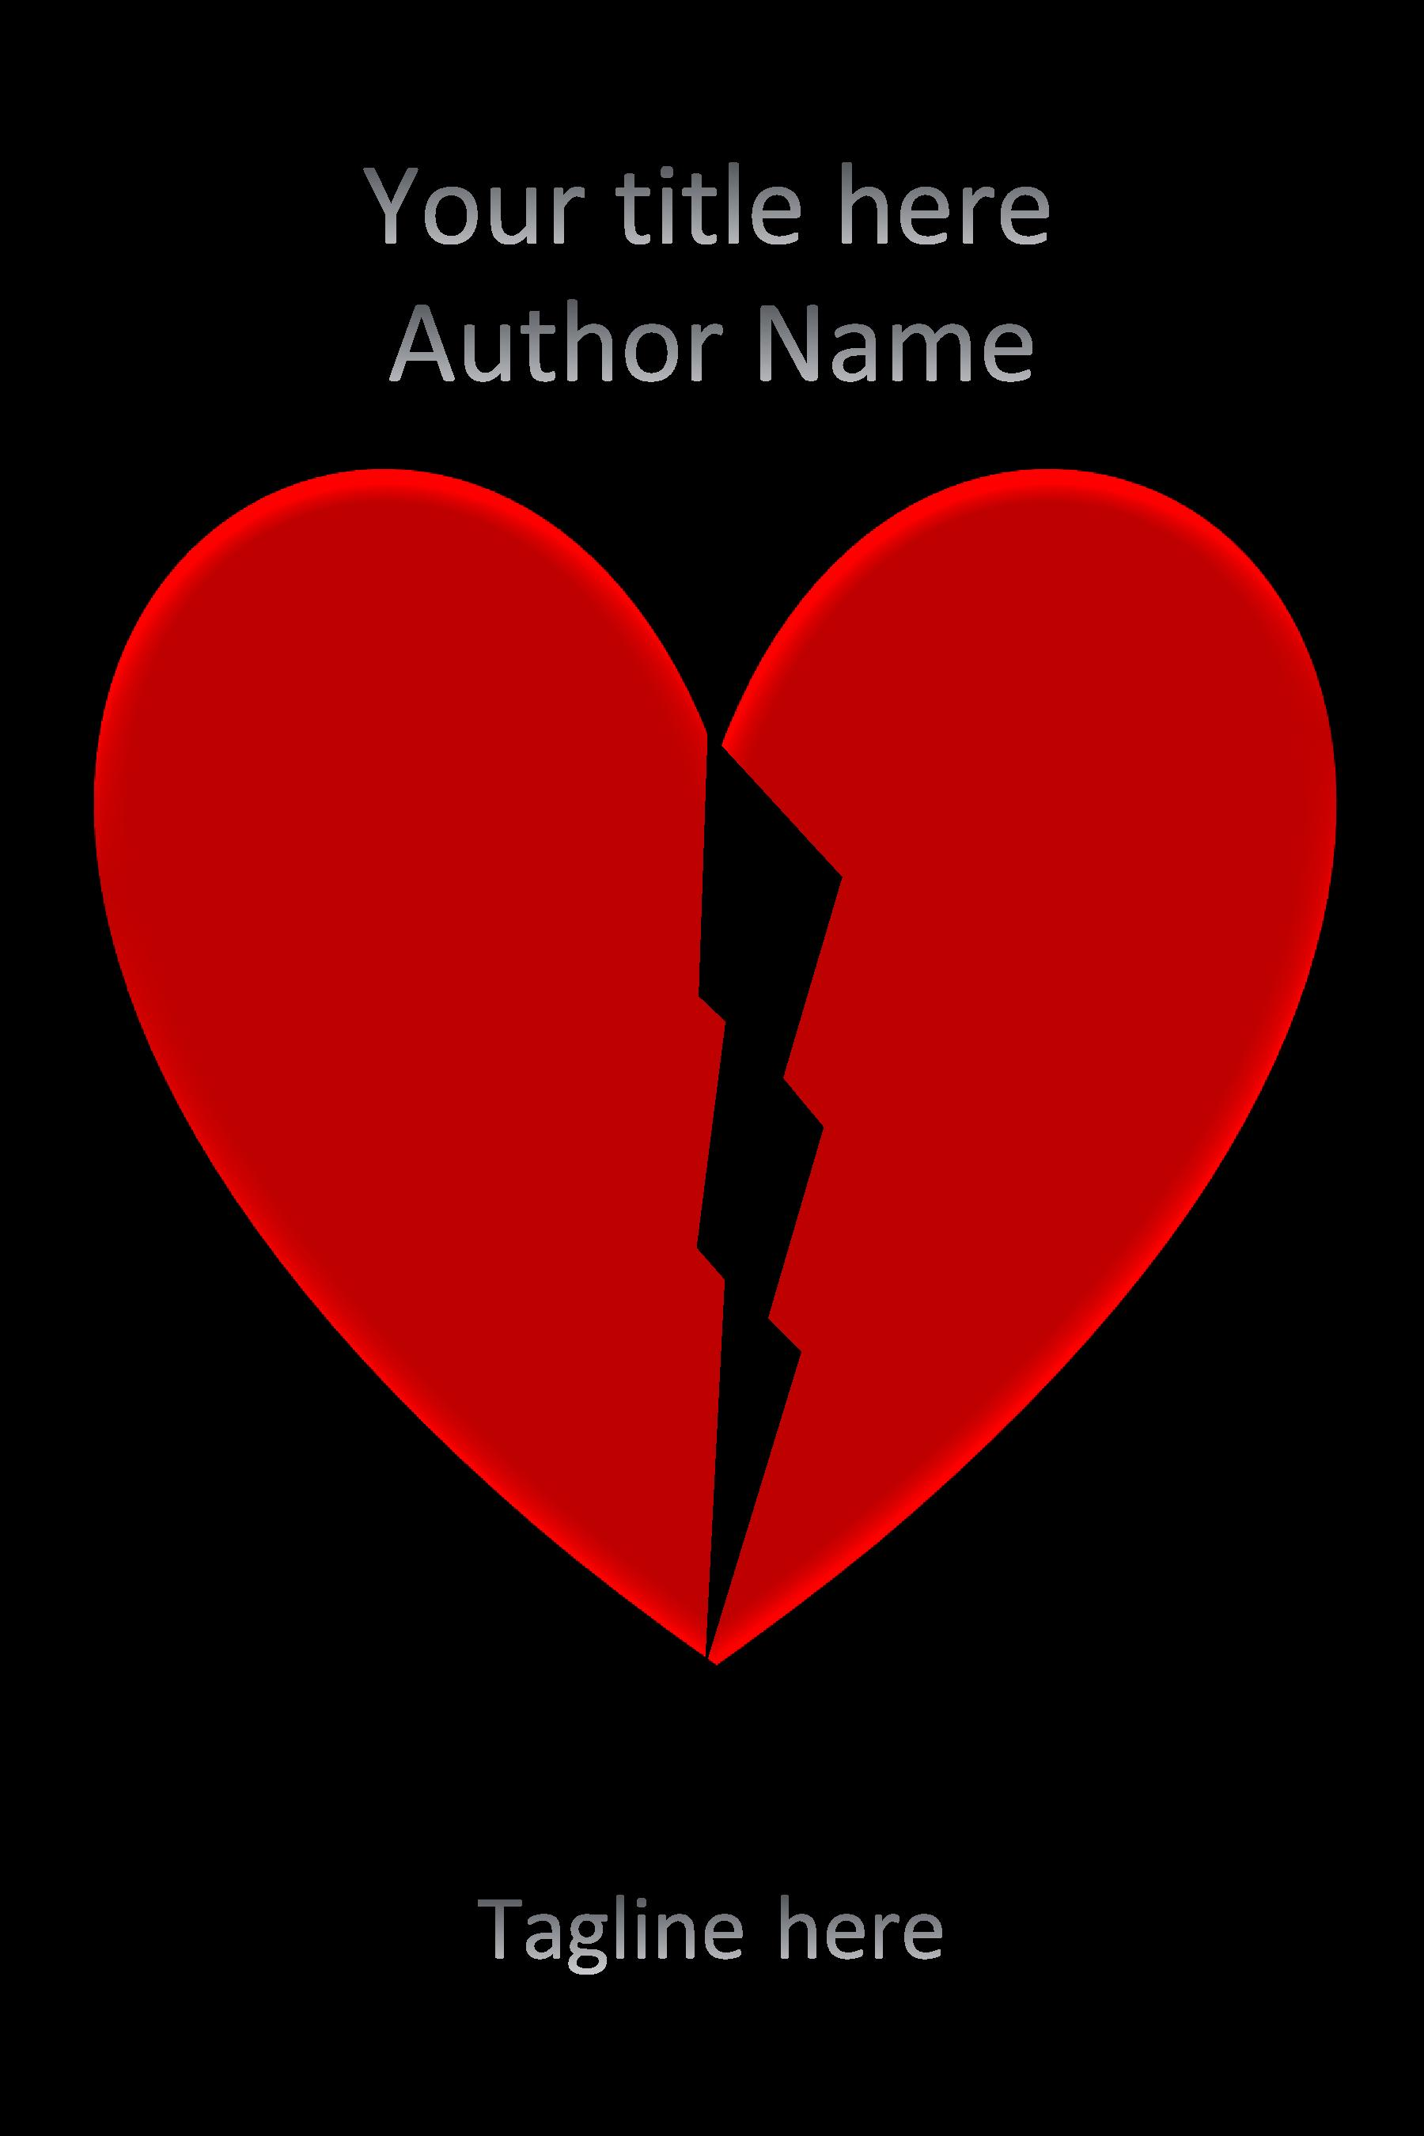

Blood Moon Rising 2

I am looking for 30 writers for Blood Moon Rising 2 which will take place in October 2015.

Authors of horror, fantasy and sci-fi only.

I have 15 writers so far and I will start to contact everyone towards the end of August.

If you are interested in taking part please contact me via email: [skgregory@hotmail.com](mailto:skgregory@hotmail.com).

You must have a book published whether traditional or self published, to take part.

I am also looking for people to blog about the event and help promote it.

The event will be on Facebook soon.



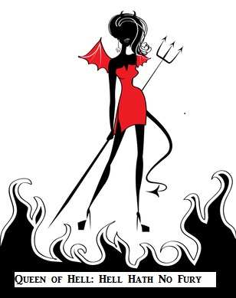

**COntact me:**

Facebook: <https://www.facebook.com/daemonpersuasion>

Twitter:

<https://twitter.com/sam_skgregory>

Goodreads: <https://www.goodreads.com/author/show/6574558.S_K_Gregory>

Email: [skgregory@hotmail.com](mailto:skgregory@hotmail.com)

All of my books are available from Amazon.