**January 8, 2015**



Queen of Hell

Welcome to 2015

This is my first author and reviewer newsletter. I will be producing a newsletter each month to keep everyone up to date on news, reviews, competitions and more.

I have a lot of projects in the works for 2015. My new series Queen of Hell: Hell Hath No Fury is with the publisher and I am working on getting the sequel finished called Hellbound. The series will be a trilogy.

On top of that I will be working on the prequel to After, which is entitled Before. Set in the present day, it tells the story of how the zombies came to be and includes two characters from After – Jack and Danny. I aim to have this finished by the beginning of March.

I am also working on a yet untitled novel for J Ellington Ashton Press featuring rattle snakes.

I am still offering free reviews to authors which may feature on my blog.

It’s going to be a busy year!

Thanks for reading,

Sam

**Reviews**

I offer free reviews to authors via my website:

[www.storyteller-skgregory.weebly.com](http://www.storyteller-skgregory.weebly.com).

I prefer horror, sci-fi, action and thrillers although I will consider other genres.

You can contact me using the contact sheet on the site.

You can also follow my blog through Networked Blogs and you can follow me on Goodreads at:

<https://www.goodreads.com/author/show/6574558.S_K_Gregory>

I am now offering copy editing and proofreading through the site too.



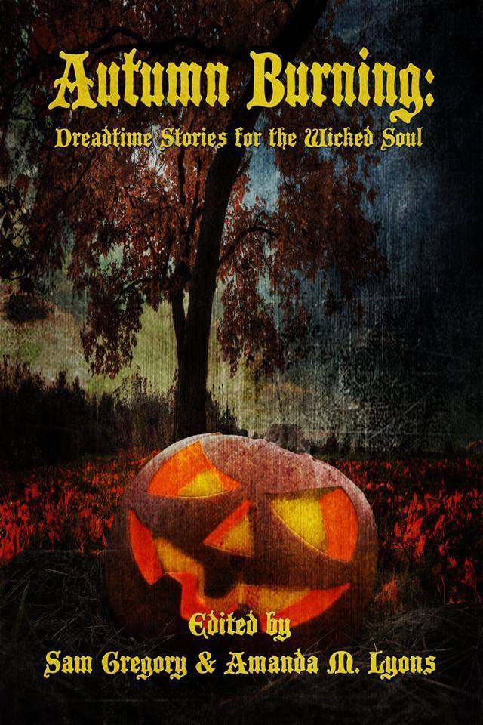

Autumn Burning – Available on Amazon

This month J Ellington Ashton Press will be hosting an online convention for their writers. It is free to go in and features some great authors, competitions and prizes. To check it out go to: [www.jeapalooza.com](http://www.jeapalooza.com).

**Special Guests**

Horror Writer's Association  
Haunted Nights Live  
David P. Forsyth  
ApocaCon  
Terry M. West  
Jennifer Sage  
Cedric Nye  
Creative Paramita  
Scott M. Baker  
Sephera Giron  
Gabrielle Faust  
Lucy Taylor  
Zombie Guide Magazine  
The Unhinged Knitter

**COntact me:**

Facebook: <https://www.facebook.com/daemonpersuasion>

Twitter:

<https://twitter.com/sam_skgregory>

Goodreads: <https://www.goodreads.com/author/show/6574558.S_K_Gregory>

Email: [skgregory@hotmail.com](mailto:skgregory@hotmail.com)

All of my books are available from Amazon.

