**September 26, 2015**

**Special Promo offer for Authors**

## The Complete Package £75

This brand new limited time offer is called the Complete Package and the aim is to provide the tools for new writers to help them get their book published.   
I am offering beta reading and editing services for your novel, cover design, promotion to over 60k potential customers and useful advice and tips on how to create a prescence online.  
This offer is available for £75.   
 I will take you from that first draft until you hit the publish button on your chosen platform or send the book off to an agent.   
When you consider that these individual services can run into hundreds, sometimes thousands of pounds, this is a great offer. This isn't a gimmick. There are no hidden catches. I know how hard and expensive it is to get started. I've learned a lot in the last few years and I want to help other writers.



NEWS

Blood Moon Rising 2 starts on October 1st. 30 writers will be taking part in the horror, sci-fi and fantasy genres.

October 1st- Introduction to the event  
2nd - [Kindra Sowder](https://www.facebook.com/kindra.kinnamanreeves)  
3rd - [Jack Rollins](https://www.facebook.com/jack.rollins.7587)  
4th - [Toneye Blakk](https://www.facebook.com/toneyeblakk)  
5th - [Kat Gracey](https://www.facebook.com/kat.gracey.9)  
6th - [Michael Noe](https://www.facebook.com/splatterpunkmonkey)  
7th - Riley Amos Westbrook   
8th - [Andy Peloquin](https://www.facebook.com/andrew.peloquin.1)  
9th - K Edwin Fritz   
10th - [Sam Gregory](https://www.facebook.com/daemonpersuasion)  
11th - [Alice J. Black](https://www.facebook.com/profile.php?id=100004968583062)  
12th - [Donald Armfield](https://www.facebook.com/profile.php?id=100002123546224)  
13th - [Sandy Spencer](https://www.facebook.com/S.M.Spencer.Author)  
14th - [Amy Vansant](https://www.facebook.com/avansant)  
15th - [Shaun Meeks](https://www.facebook.com/shaun.meeks.7)  
16th - [Author David Wind](https://www.facebook.com/authordavid.wind)  
17th - M. L. Sparrow   
18th - Ryan Hill   
19th - [Armand Rosamilia](https://www.facebook.com/armand.rosamilia)  
20th - [Jay Wilburn](https://www.facebook.com/writerjaywilburn)  
21st- Nina Croft  
22nd - [Sharon Higa](https://www.facebook.com/sharon.higa.3)  
23rd - Ash Hartwell   
24th - Andrea Perno  
25th - C. L. Hernandez   
26th - [Michelle Garza](https://www.facebook.com/michelle.garza.98) and [Melissa Lason](https://www.facebook.com/melissa.lason)  
27th - [Stuart Keane](https://www.facebook.com/stuart.keane.92)  
28th - Kat Doughty  
29th - Kristy Feltenberger Gillespie   
30th - [Eden Royce](https://www.facebook.com/eden.royce)  
31st - Halloween Fun

We are also going to release a free anthology to go with the event. It will be available on Smashwords and will feature short stories from several of the authors taking part in the event.

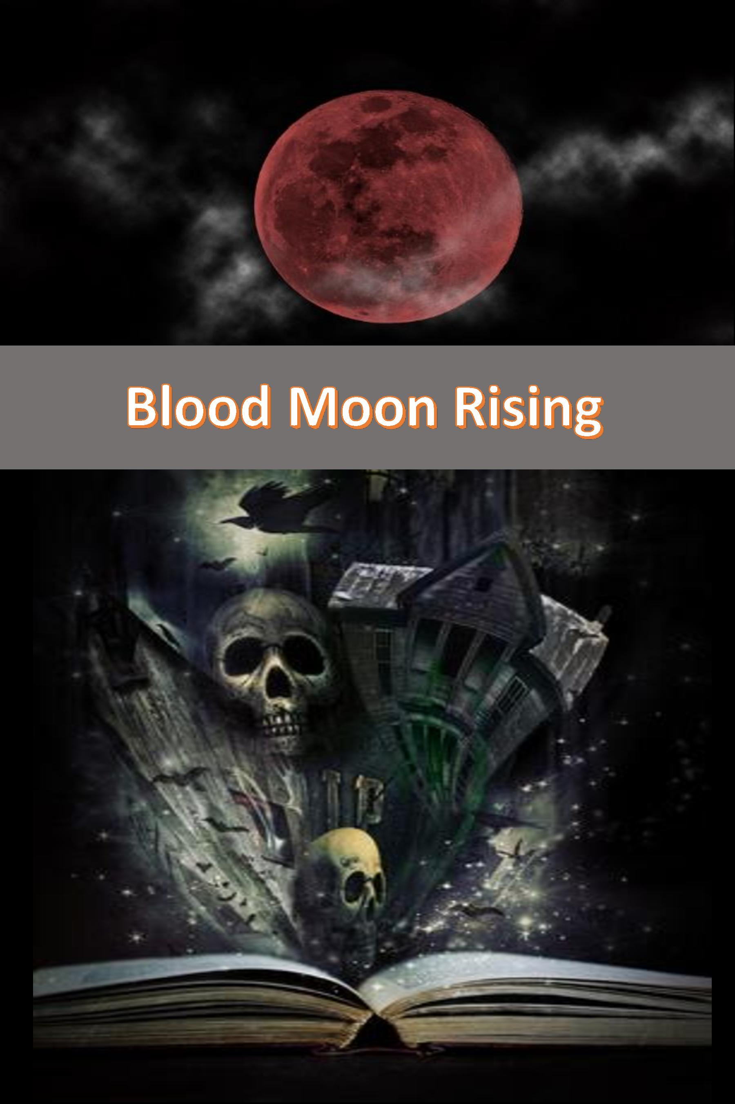

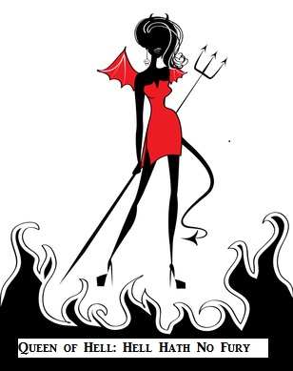

**COntact me:**

Facebook: <https://www.facebook.com/daemonpersuasion>

Twitter:

<https://twitter.com/sam_skgregory>

Goodreads: <https://www.goodreads.com/author/show/6574558.S_K_Gregory>

Email: [skgregory@hotmail.com](mailto:skgregory@hotmail.com)

All of my books are available from Amazon.